|  |  |
| --- | --- |
| **NAME** | **ID** |
| **FAHIM, SHEIKH FARHAN** | **17-35984-3** |
| **Sadia Mubbassira Chowdhury** | **20-43407-1** |
| **Sumaya jahan kanta** | **20-41853-1** |
| **ARIFA, MUSHARRAT** | **18-37707-1** |

**AMERICAN INTERNATIONAL**

**UNIVERSITY-BANGLADESH**

**Faculty of Science and Information Technology**

**Course Name: Introduction To Database.**

**Faculty Name: JUENA AHMED NOSHIN**

**Section: L**

**Project Name: Super Shop Management System.**

**CONTENTS:**

|  |  |
| --- | --- |
| **PAGE NUMBER** | **TOPIC NAME** |
| **1** | **COVER PAGE** |
| **2** | **CONTENTS** |
| **3** | **INTRODUCTION** |
| **4** | **SCENARIO DESCRIPTION,ER DIAGRAM** |
| **5,6,7,8,9** | **NORMALIZATION** |
| **10** | **SCHEMA DIAGRAM** |
| **11,12,13,14,15,16,17** | **TABLE CREATION** |
| **18** | **DATA INSERTION** |
| **18,19,20,21,22,23** | **QUERY WRITING** |
| **23** | **RELATIONAL ALGEBRA** |
|  |  |

**INTRODUCTION:**

This documentation has been prepared to give an overview of the Super shop management software system specification for the real-life projects that each student of Database Design and Development course Project has to develop and implement group. Super shop management software system should be purchased from software package vendors and customised to the departmental Super shop’s needs, if necessary. Customer service refers to a departmental Super shop ability to satisfy the needs of its customers by this Super shop management software system.

**Primary Keys**

•         CUSTOMER – CUSTOMER_ID

•         BILL - BILL_NO.

•         EMPLOYEE – EMP_ID

•         DISTRIBUTER- DISTRIBUTER_ID

•         PRODUCT- PRODUCT_ID

**Relationships**

•         Customer – Customer ID – Billing Counter

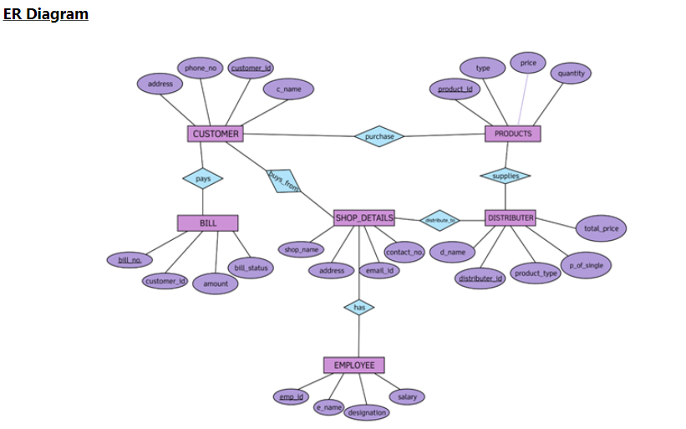

**NORMALIZATION:**

**Served by:**

**UNF**

Served by (customer id, customer_ name, phone no, shop id, shop_ name, house_ no,

street name, city)

**1NF**

phone no is a multi-value attribute

1. customer id, customer_name, phone no, shop id, shop_ name, house_ no, street_

name, city

**2NF**

1. customer id, customer_name, phone no

2. shop_id, shop_name, house_ no, street_name, city

**3NF**

**There is no transitive dependency. Relation is already in 3NF**

1. customer id, customer_name, phone no

2. shop_id, shop_name, house_no, street_name, city

**Table Creation**

1. customer id, customer_name, phone no, shop_id

2. shop_id, shop_name, house_ no, street_name, city

**Order**

**UNF**

Order (product id, product type, price, customer id, customer_name, phone no)

**1NF**

phone no is a multi-value attribute

1. product id, product _type, price, customer id, customer_name, phone no

**2NF**

1. product id, product_type, price

2. customer id, customer_name, phone no

**3NF**

**There is no transitive dependency. Relation is already in 3NF**

1. product id, product _type, price

2. customer id, customer_name, phone no

**Table Creation**

1. product id, product _type, price

2. customer id, customer_name, phone no

3. **product id, customer_id**

**Pay**

**UNF**

Pay (bill id, amount, customer id, customer_name, phone no)

**1NF**

phone no is a multi-value attribute

bill id, amount, customer id, customer_name, phone no

**2NF**

1. bill id, amount

2. customer id, customer_name, phone no

**3NF**

**There is no transitive dependency. Relation is already in 3NF**

1. bill id, amount

2. customer id, customer_name, phone no

**Table Creation**

1. bill id, amount

2. customer id, customer_name, phone no

3. **bill id, customer id**

**Work:**

**UNF:**

Work (Shop id , shop_ name, house_ no, street_ name, City, employee id, employee_ name, salary, designation)

**1NF:**

There is no multi valued attribute.

1.Shop id , shop_ name, house_ no, street_ name, City, employee id, employee_ name, salary, designation

**2NF:**

1.Shop id,Shop_name, house_no, Street_name, City

2.employee Id, employee_name, Salary, designation

**3NF:**

There is no transitive dependency.The Relation is already in 3NF

1.Shop id,Shop_name, house_no, Street_name, City

2.employee Id, employee_name, Salary, designation

**TABLE CREATION:**

1.Shop id,Shop_name, house_no, Street_name, City

2..employee id, employee_name, Salary, designation,Shop Id .

Owned by:

Owned by (Shop id, Shop_name, house_no, Street_name, City,Owner id, Owner _name)

**1NF:**

There is no multi valued attribute.

1.Shop id, Shop_name, house_no, Street_name, City,Owner id, Owner _name

**2NF:**

1.Shop id, Shop_name, house_no, Street_name, City

2.Owner Id, Owner_name

**3NF:**

There is no transitive dependency.The Relation is already in 3NF.

1.Shop id ,Shop_name, house_no, Street_name, City

2.Owner Id, Owner_name

**Table Creation:**

1. Shop id,Shop_name, house_no, Street_name, City

2.Owner Id, Owner_name,Shop_id.

Temporary Table:

1.Customer id, Customer _name, Phone no,Shop_id

2.Shop id,Shop_name, house_no, Street_name, City

3.Product id, Customer id

4.bill id, amount.

5.bill id, Customer id.

6.employee id, employee _name, salary, designation,shop_id

7.Owner id, Owner _name,Shop _id.

**Final Table:**

1.Customer id, Customer _name, Phone no 1, phone no2, Phone no 3.......... phone no n

Shop _id

2 .Shop id,Shop_name, house_no, Street_name, City

3.product id , product _type, price

4.Product id, Customer id

5.bill id, amount

6.employee id, employee _name, salary, designation,shop_id

7.Owner id , Owner _name ,Shop _id.

8.bill id, customer id

**SCHEMA DIAGRAM:**

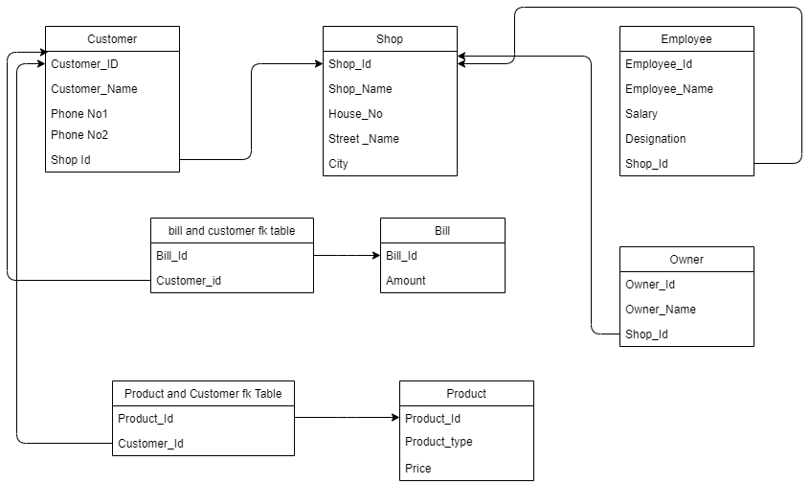

**Table Creation:**

➢ CREATE USER Isopropyl IDENTIFIED BY net23xyz;

➢ GRANT UNLIMITED TABLESPACE TO Isopropyl;

➢ CREATE ROLE Accounts;

➢ GRANT create table, create view, create sequence to Accounts;

➢ GRANT Accounts to Isopropyl;

➢ ALTER USER Isopropyl IDENTIFIED BY net345abc;

* **For Shop Table :**

create table shop (shop_id number (3) primary key,shop_name varchar2(50) not null,house_no varchar2(50) not null,street_name varchar2(50) not null,city varchar2(50) not null);

Describe shop;

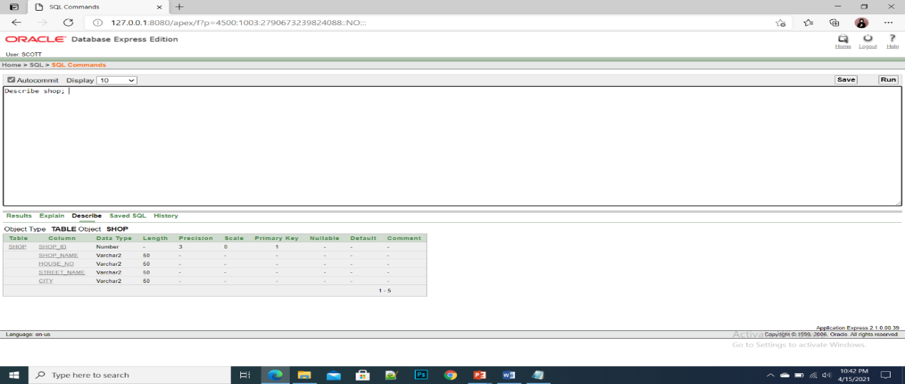

* **For Customer Table :**

create table customer (customer_id number(3) primary key,customer_name varchar2(50) not null,phone_no1 number(15) not null,phone_no2 number(15) not null,shop_id number(3) not null,foreign key(shop_id) references shop(shop_id));

Describe customer;

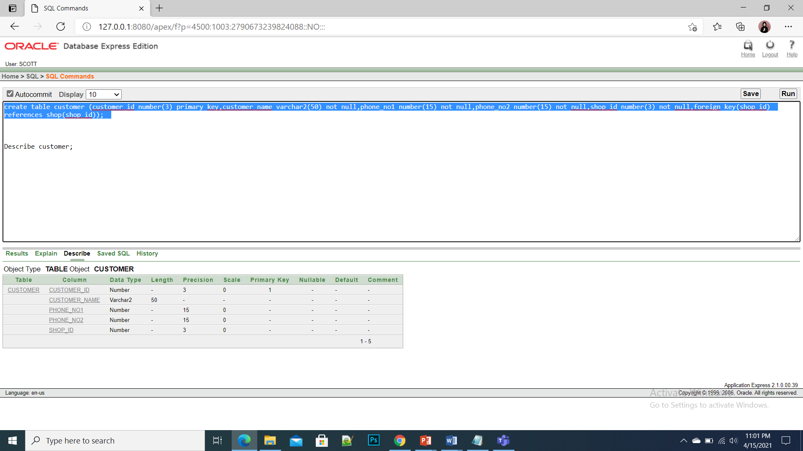

**3. For Employee Table :**

create table employee (employee_id number (3) primary key,employee_name varchar2(50) not null,salary number(20) not null,designation varchar2(50) not null,shop_id number(3) not null,foreign key(shop_id) references shop(shop_id));

Describe employee;

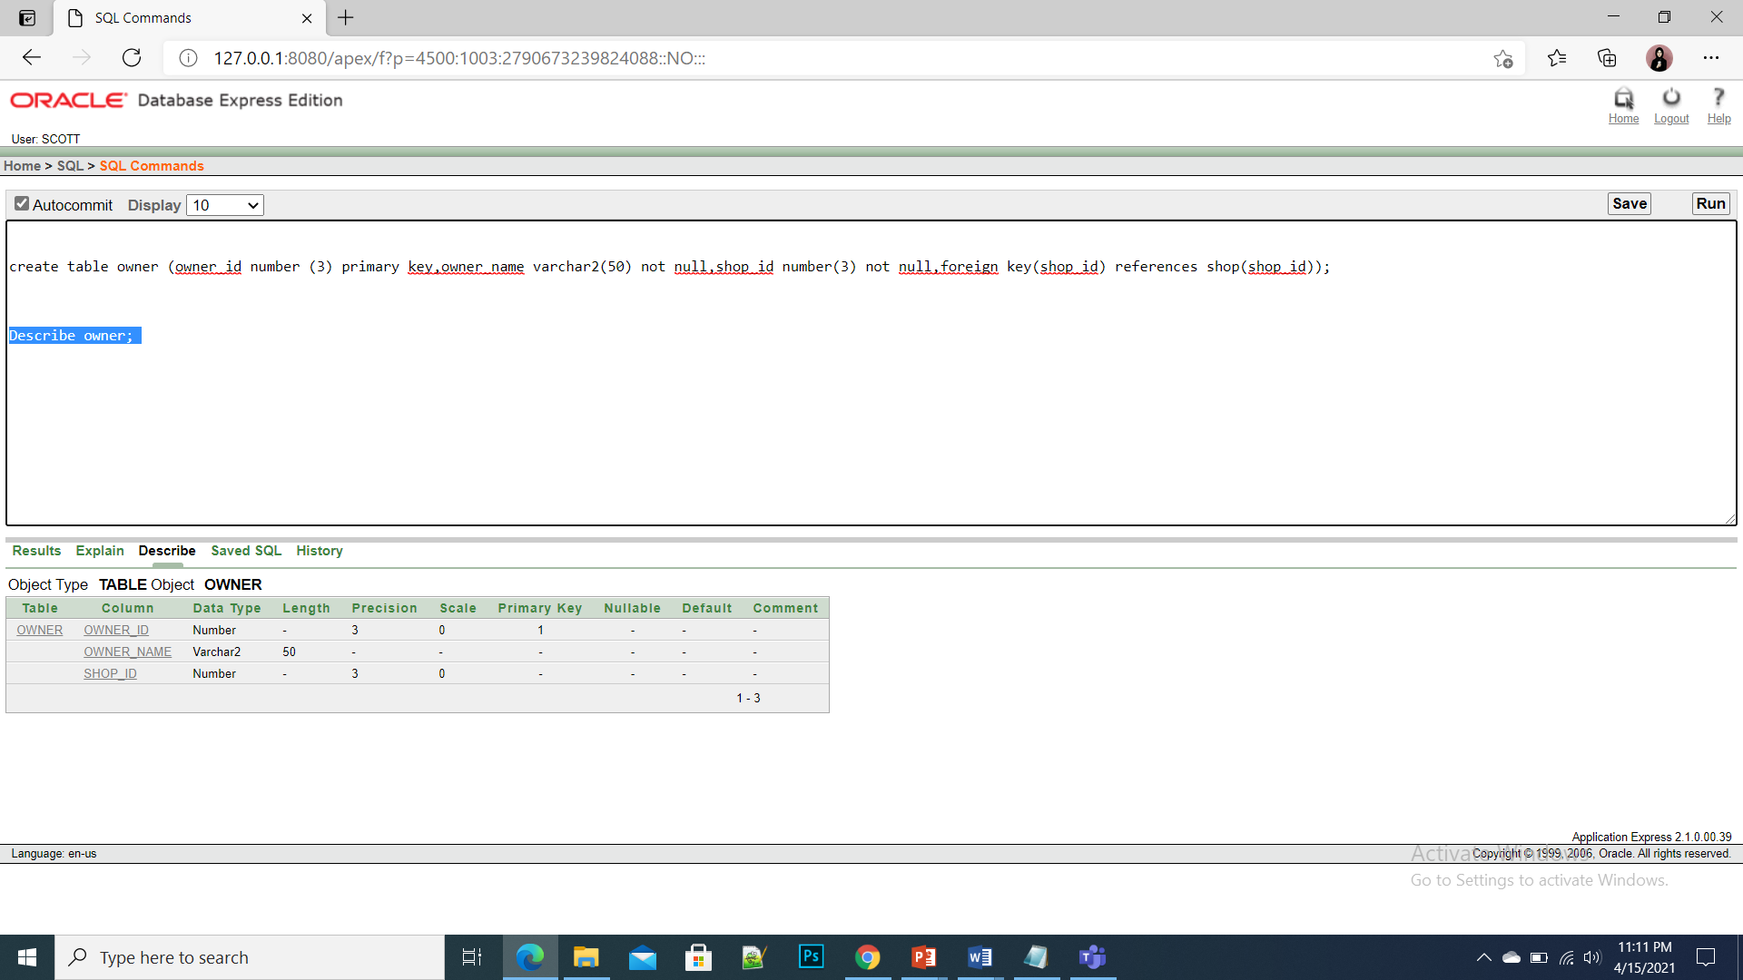

**4. For Owner Table**

create table owner (owner_id number (3) primary key,owner_name varchar2(50) not null,shop_id number(3) not null,foreign key(shop_id) references shop(shop_id));

Describe owner;

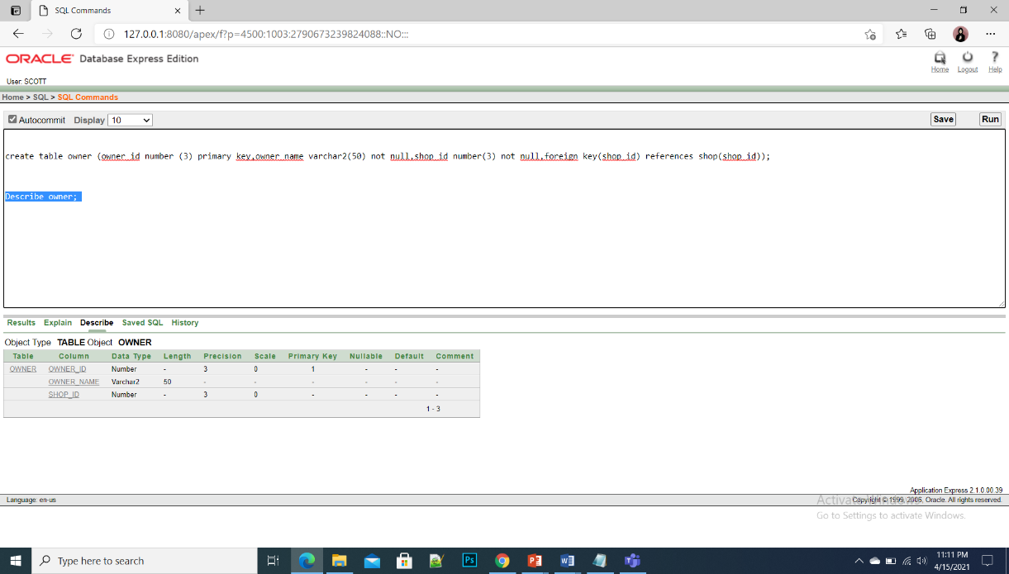

**5. For Bill Table**

create table bill (bill_id number (3) primary key, amount varchar2(50) not null);

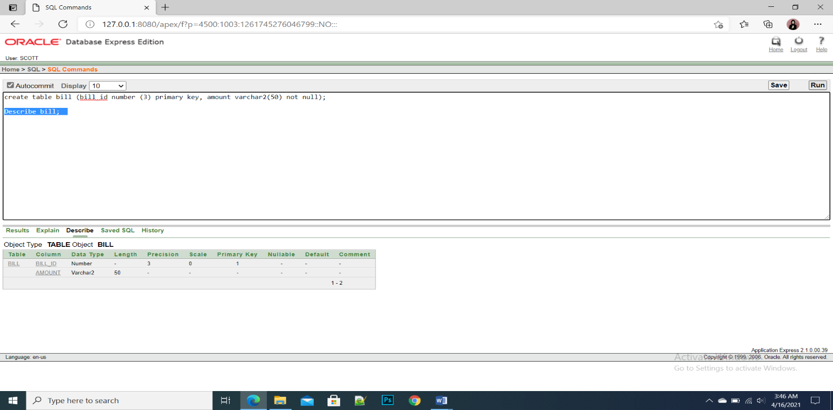Describe bill;

**6. For Product Table**

create table product(product_id number (3) primary key,product_type varchar2(50) unique,price

varchar2(50) not null);

Describe product;

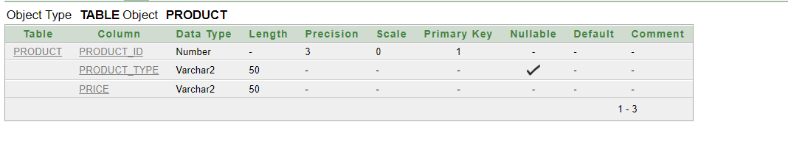

**7. For product and customer fk Table**

Create table product_and_customer_fk_table(product_id number(3)not null,foreign key(product_id)references product(product_id),customer_id number(3) not null,foreign

key(customer_id)references customer(customer_id),constraint p_pk primary key(product_id,customer_id));

Describe product _and_customer_fk_table;

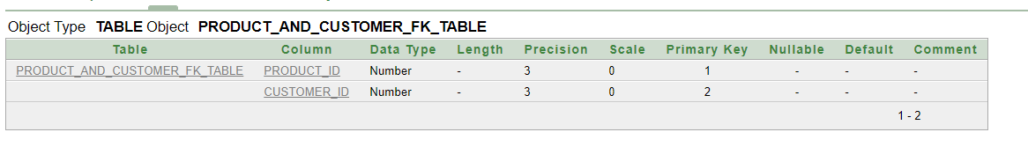

**8. For bill and customer fk Table**

create table bill_and_customer_fk_table ( bill_id number(3) not null,foreign key(bill_id)references bill(bill_id),customer_id number(3) not null,foreign key(customer_id) references customer (customer_id) ,constraint t_pk1 primary key (bill_id,customer_id));

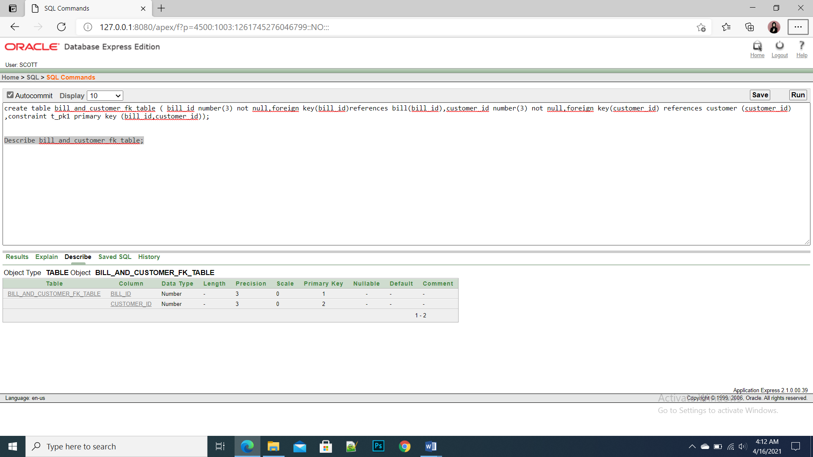Describe bill_and_customer_fk_table;

**Sequence**

* create sequence shop_id_seq increment by 1 start with 100 maxvalue 999;
* create sequence customer_id_seq increment by 1 start with 200 maxvalue 999;
* create sequence employee_id_seq increment by 1 start with 300 maxvalue 999;
* create sequence owner_id_seq increment by 1 start with 400 maxvalue 999;
* create sequence bill_id_seq increment by 1 start with 500 maxvalue 999;
* create sequence product_id_seq increment by 1 start with 600 maxvalue 999;

**DATA INSERTION :**

**1. For Shop Table**

insert into shop (shop_id,shop_name ,house_no,street_name,city)values(shop_id_seq.NEXTVAL,'ABC','55/B','Baily Road','DHAKA');

insert into shop (shop_id,shop_name ,house_no,street_name,city)values(shop_id_seq.NEXTVAL,'DEF','64/A','Shohid Bir Uttam Road','DHAKA');

insert into shop (shop_id,shop_name ,house_no,street_name,city)values(shop_id_seq.NEXTVAL,'XYZ','191/A','Abdullah Khan Road','CHITTAGONG');

insert into shop (shop_id,shop_name ,house_no,street_name,city)values(shop_id_seq.NEXTVAL,'MNO','109/L','Abu Mia Road','PABNA');

insert into shop (shop_id,shop_name ,house_no,street_name,city)values(shop_id_seq.NEXTVAL,'JKL','76/B','Merajnagar Road','DHAKA');

insert into shop (shop_id,shop_name ,house_no,street_name,city)values(shop_id_seq.NEXTVAL,'EFG','58/C','Jamal Khan Road','KHULNA');

SELECT *FROM SHOP;

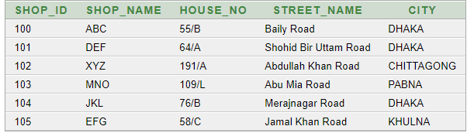

**2. For Customer Table**

* INSERT INTO customer(customer_id, customer_name,phone_no1,phone_no2,shop_id)

values(customer_id_seq.NEXTVAL,'RAJ','8801711318734','8801552392801','100');

* INSERT INTO customer(customer_id,customer_name,phone_no1,phone_no2,shop_id)

values(customer_id_seq.NEXTVAL,'SAMIUN','8801723210623','88019107499455','101'

);

* INSERT INTO customer(customer_id,customer_name,phone_no1,phone_no2,shop_id)

values(customer_id_seq.NEXTVAL,'Kamal','88015865448796','880156586586','102');

* INSERT INTO customer(customer_id,customer_name,phone_no1,phone_no2,shop_id)

values(customer_id_seq.NEXTVAL,'Badol','8801847265122','8801313054598','103');

* INSERT INTO customer(customer_id,customer_name,phone_no1,phone_no2,shop_id)

values(customer_id_seq.NEXTVAL,'Santa','8801552349494','8801722629237','104');

* INSERT INTO customer(customer_id,customer_name,phone_no1,phone_no2,shop_id)

values(customer_id_seq.NEXTVAL,'Rima','8801747440554','8801955997675','105');

SELECT *FROM CUSTOMER;

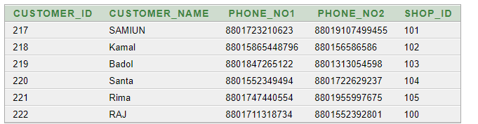

**3. For Employee Table:**

* insert into employee (employee_id, employee_name, salary, designation, shop_id)values (employee_id_seq.NEXTVAL, 'Salman', 5000, 'CHEF', '101');
* insert into employee (employee_id, employee_name, salary, designation, shop_id)values (employee_id_seq.NEXTVAL, 'Rana', 6500, 'MANAGER', '102');
* insert into employee (employee_id, employee_name, salary, designation, shop_id)values (employee_id_seq. NEXTVAL, 'RONY', 3000, 'WAITER', '101');
* insert into employee (employee_id, employee_name, salary, designation, shop_id)values (employee_id_seq. NEXTVAL, 'RAKHI', 6500, 'MANAGER', '103');
* insert into employee (employee_id, employee_name, salary, designation, shop_id)values (employee_id_seq. NEXTVAL, 'JONY', 3000, 'WAITER', '103');
* insert into employee (employee_id, employee_name, salary, designation, shop_id)values (employee_id_seq .NEXTVAL, 'KAMRUL', 5000, 'CHEF', '103');
* insert into employee (employee_id, employee_name, salary, designation, shop_id)values (employee_id_seq.NEXTVAL,'BADON',2500,'WAITER','102');
* insert into employee (employee_id,employee_name,salary,designation,shop_id)values(employee_id_seq.NEXTVAL,'ATIK',4000,'CHEF','102');
* insert into employee (employee_id,employee_name,salary,designation,shop_id)values(employee_id_seq.NEXTVAL,'ALVI',6000,'MANAGER','102');
* insert into employee (employee_id,employee_name,salary,designation,shop_id)values (employee_id_seq.NEXTVAL,'MINHAZ',3000,'WAITER','104');
* insert into employee (employee_id,employee_name,salary,designation,shop_id)values(employee_id_seq.NEXTVAL,'BORNA',5500,'CHEF','104');
* insert into employee (employee_id,employee_name,salary,designation,shop_id)values (employee_id_seq.NEXTVAL,'SHAKIL',6000,'MANAGER','100');
* insert into employee (employee_id,employee_name,salary,designation,shop_id)values (employee_id_seq.NEXTVAL,'RONY',3000,'WAITER','100');
* insert into employee (employee_id,employee_name,salary,designation,shop_id)values(employee_id_seq. NEXTVAL,'FATEMA',5000,'CHEF','100');
* insert into employee (employee_id,employee_name,salary,designation,shop_id)values(employee_id_seq. NEXTVAL,'SHIRAJ',3500,'CASHIER','101');
* insert into employee (employee_id,employee_name,salary,designation,shop_id)values(employee_id_seq. NEXTVAL,'SAKIB',3500,'CASHIER','102');
* insert into employee (employee_id,employee_name,salary,designation,shop_id)values(employee_id_seq. NEXTVAL,'RAISA',3500,'CASHIER','104');
* insert into employee (employee_id, employee_name, salary, designation, shop_id)values (employee_id_seq. NEXTVAL,'ANIKA',3500,'CASHIER','100');

SELECT *FROM EMPLOYEE;

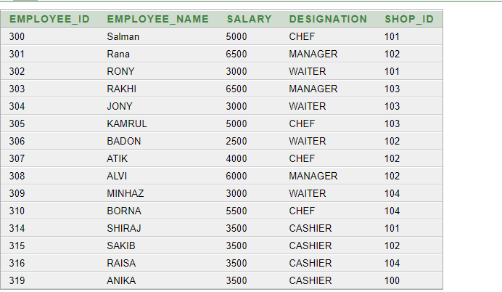

**4. For Owner Table:**

* insert into owner (owner_id, owner_name, shop_id) values (owner_id_seq.NEXTVAL,'Amin',100 );
* insert into owner (owner_id, owner_name, shop_id) values (owner_id_seq.NEXTVAL,'Rakib',104 );
* insert into owner (owner_id, owner_name, shop_id) values (owner_id_seq.NEXTVAL,'Tomal',102 );
* insert into owner (owner_id, owner_name, shop_id) values (owner_id_seq.NEXTVAL,'Noshad',103 );
* insert into owner (owner_id, owner_name, shop_id) values (owner_id_seq.NEXTVAL,'Tamil',101 );

SELECT *FROM OWNER

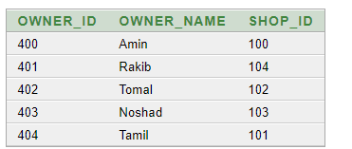

**5. For Bill Table:**

* INSERT INTO bill (bill_id,amount)VALUES(bill_id_seq.NEXTVAL,'450');
* INSERT INTO bill (bill_id,amount)VALUES(bill_id_seq.NEXTVAL,'250');
* INSERT INTO bill (bill_id,amount)VALUES(bill_id_seq.NEXTVAL,'500');
* INSERT INTO bill (bill_id,amount)VALUES(bill_id_seq.NEXTVAL,'200');
* INSERT INTO bill (bill_id,amount)VALUES(bill_id_seq.NEXTVAL,'50');
* INSERT INTO bill (bill_id,amount)VALUES(bill_id_seq.NEXTVAL,'150');
* INSERT INTO bill (bill_id,amount)VALUES(bill_id_seq.NEXTVAL,'350');
* INSERT INTO bill (bill_id,amount)VALUES(bill_id_seq.NEXTVAL,'200');
* INSERT INTO bill (bill_id,amount)VALUES(bill_id_seq.NEXTVAL,'90');
* INSERT INTO bill (bill_id,amount)VALUES(bill_id_seq.NEXTVAL,'90');
* INSERT INTO bill (bill_id,amount)VALUES(bill_id_seq.NEXTVAL,'55');
* INSERT INTO bill (bill_id,amount)VALUES(bill_id_seq.NEXTVAL,'500');
* INSERT INTO bill (bill_id,amount)VALUES(bill_id_seq.NEXTVAL,'300');
* INSERT INTO bill (bill_id,amount)VALUES(bill_id_seq.NEXTVAL,'200');
* INSERT INTO bill (bill_id,amount)VALUES(bill_id_seq.NEXTVAL,'100');

SELECT *FROM BILL;

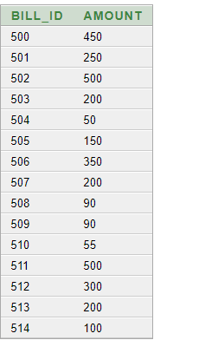

**6. FOR PRODUCT TABLE:**

* INSERT INTO PRODUCT (product_id, product_type,price) VALUES (product_id_seq.NEXTVAL,

'HOLUS GURA(500gm)', '40');

* INSERT INTO PRODUCT(product_id,product_type,price) VALUES (product_id_seq.NEXTVAL,

'MORICH GURA(500gm)','50');

* INSERT INTO PRODUCT (product_id, product_type, price) VALUES (product_id_seq.NEXTVAL,'ICE CREAM', '150');
* INSERT INTO PRODUCT (product_id, product_type, price) VALUES (product_id_seq.NEXTVAL,'CHICKEN (2kg)', '550');
* INSERT INTO PRODUCT (product_id,product_type, price) VALUES (product_id_seq.NEXTVAL,'CHOCOLATE', '200');

• INSERT INTO product (product_id, product_type, price) VALUES (product_id_seq.NEXTVAL,

'SHAMPOO', '500');

• INSERT INTO product (product_id, product_type, price) VALUES (product_id_seq.NEXTVAL,

'COOKIES', '90');

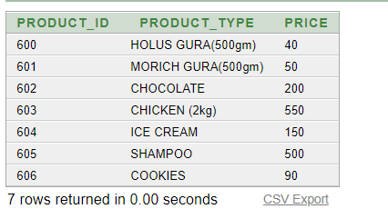

**7.For product and customer fk Table:**

INSERT INTO product_and_customer_fk_table(product_id ,customer_id)VALUES('600','217');

INSERT INTO product_and_customer_fk_table(product_id ,customer_id)VALUES('604','219');

INSERT INTO product_and_customer_fk_table(product_id ,customer_id)VALUES('602','221');

INSERT INTO product_and_customer_fk_table(product_id ,customer_id)VALUES('605','222');

INSERT INTO product_and_customer_fk_table(product_id ,customer_id)VALUES('601','221');

INSERT INTO product_and_customer_fk_table(product_id ,customer_id)VALUES('606','218');

SELECT *FROM product_and_customer_fk_table;

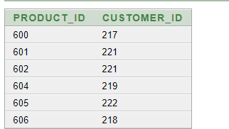

**8. For Bill and customer fk Table:**

INSERT INTO bill_and_customer_fk_table(bill_id ,customer_id)VALUES('500','217');

INSERT INTO bill_and_customer_fk_table(bill_id ,customer_id)VALUES('501','218');

INSERT INTO bill_and_customer_fk_table(bill_id ,customer_id)VALUES('503','221');

INSERT INTO bill_and_customer_fk_table(bill_id ,customer_id)VALUES('504','219');

INSERT INTO bill_and_customer_fk_table(bill_id ,customer_id)VALUES('502','222');

SELECT *FROM bill_and_customer_fk_table;

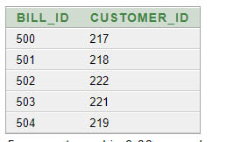

**SQL Queries:**

**Question:** Display the employee names who earn less than employee KAMRUL.

**ANSWER:** select employee_name from employee where salary<(select salary from

employee where employee_name='KAMRUL');

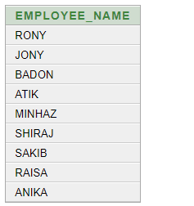

**Question:** Display the employee names and employee id who have the same designation as employee BADON

Answer: select employee_name,employee_id from employee where designation=(select designation from employee where employee_name='BADON');

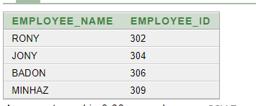

**2. Joining**

**Question: Display the name of all the customers who eat in shop DEF.**

**Answer:** **SELECT c.customer_name FROM customer c, shop s WHERE c.shop_id=s.shop_id**

**and shop_name='DEF';**

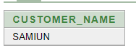

**Question:** Display the name of all the employess who work in shop JKL.

**ANSWER:**SELECT e.employee_name FROM employee e, shop s WHERE e.shop_id=s.shop_id and shop_name='JKL';

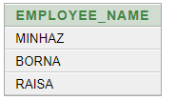

**RELATIONAL ALGEBRA:**

1. Find the name of the customer whose id is 2001

***∏customer_name (σ customer_id=“2001”(CUSTOMER))***

2. Find the bill where amount is greater than $3004

**∏*amount* (σ*amount* > 3004 (*BILL*))**

3. Find the Employee name where Employee name is 'Suresh'

**∏*f_name* (σ*f_name*=“Suresh” (*Employee*))**

4. Find the Product type product type is 'Bath Soap'

**∏*product_type* (σ*product_type*=“Bath Soap” (*DISTRIBUTER*))**

5. Find Product Id and price where price is 30

**∏*product_id,price* (σ*price*=“30” (*BILL*))**